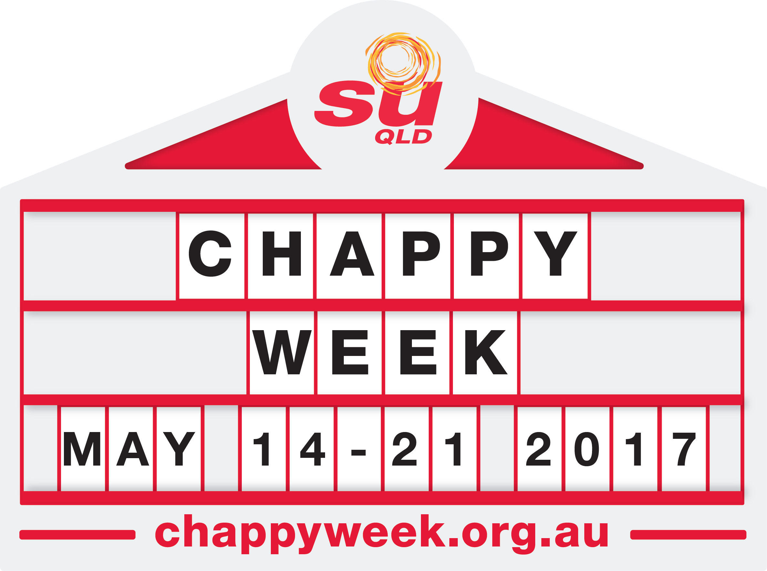
***MEDIA ALERT***

A week to celebrate our local ‘chappy’!

[Insert date]

School chaplains in [city/suburb/region] will celebrate Chappy Week with [insert event name] at [school] on [insert date].

Chappy Week is held annually in around 800 schools state-wide to celebrate and raise awareness for the work school chaplains undertake within their communities.

Chappy Week celebrates and supports the work of school chaplains, often referred to as ‘chappies’ by students.

[Include any information that related specifically about your event, eg. If there are any special guests, how many people you expect to attend etc]

[Include a quote from the chaplain, explaining why you are running the event].

“Chappies are there to help kids deal with all that life throws at them,” said Peter James, CEO of SU QLD, the largest employing authority of school chaplains in Australia.

“On a daily basis, they appropriately support students working through issues ranging from family breakdowns to stress and anxiety,” he says.

Chaplains provide social, emotional, practical and spiritual support in Australian schools. They work in prevention and support; helping students find a positive way to deal with issues ranging from relationship and social problems, family breakdown and loneliness to support through grief, natural disaster and personal tragedy.

They provide a listening ear and a caring presence for kids in crisis, and for those who just need someone to believe in them. They are also on-hand to provide support for staff and parents in school communities.

SU QLD is officially endorsed by Education Queensland as an accredited employing authority for school chaplains. There are currently more than 580 SU QLD chaplains working in more than 800 schools across the state.

Interviews and photo opportunities can be arranged by calling the chaplain directly.

---ENDS---

Media Enquiries:
Insert Chaplains first and last name
Chaplain [include school name]
phone number
email

