

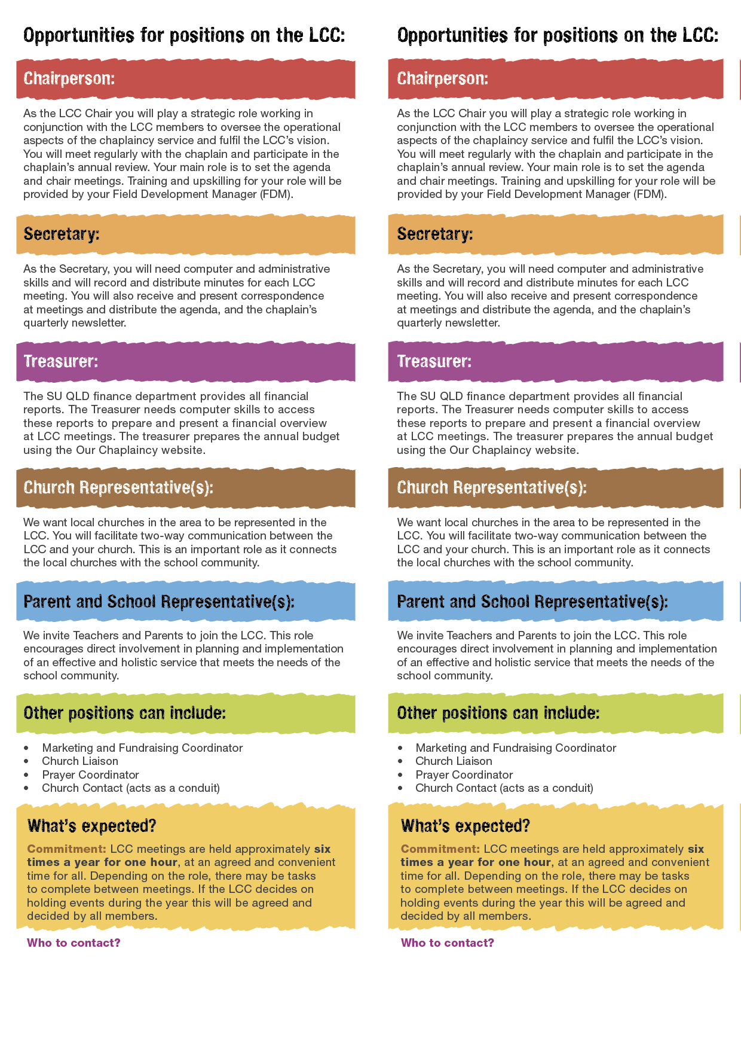

<Insert LCC Member Name>

<Insert LCC Member Title>

**<Insert email address>**

**<Insert best contact phone number>**

<Insert LCC Member Name>

<Insert LCC Member Title>

**<Insert email address>**

**<Insert best contact phone number>**